1. I allowed my Ubuntu user to access my centos server by typing the ip of my centos server into a browser.
2. 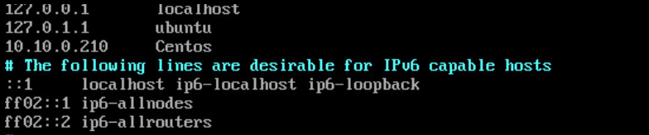
3. I secured my database by creating a root account with a password, as well as a user account with a password. The user account does not have very many permissions and doesn’t have access to a lot of the database. I also configured the root account to only be available from my Ubuntu ip and from localhost on the centos server itself.